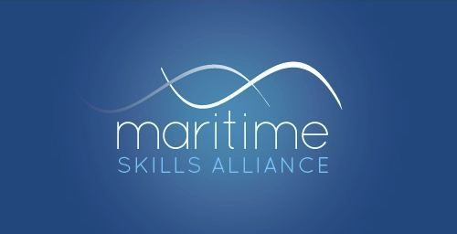
Level 3 Diploma in Maritime Studies: Shipping and Maritime Operations (Deck)

Ofqual ref: 600/0255/4 - SQA ref: GA6F 57
Candidates must achieve 56 credits (ie all the mandatory Units)
MSA Ref | Title | SQA Code | Ofqual code | QCF Level | QCF credit value | GLH
Group A: Mandatory Units
1 | Maritime Employment, Environmental and Health and Safety Practice | FA5M 54 | Y/501/2738 | 2 | 2 | 20
2 | Maritime Sector Overview | FA69 54 | D/501/2739 | 2 | 3 | 30
3 | Vessel Ropework, Anchoring and Mooring Operations | FA60 54 | K/602/3897 | 2 | 5 | 50
4 | Securing a Vessel for Passage | FA61 54 | H/602/3901 | 2 | 3 | 28
5 | Vessel Construction and Stability | FA62 54 | T/602/3904 | 2 | 5 | 50
10 | Assist with a Vessel's Navigational Watch | FA63 54 | J/602/3907 | 2 | 3 | 28
29 | Control Operation of Survival Craft and Rescue Boats | FF2D 57 | L/602/5321 | 3 | 3 | 30
30 | Control vessel operations | FF22 57 | L/602/5352 | 3 | 8 | 70
34 | Mathematics for seafarers | FF24 57 | R/602/5773 | 3 | 5 | 40
35 | Nautical Science - an Introduction | FF2A 57 | A/502/7118 | 3 | 8 | 70
36 | Numeracy for seafarers | FF23 60 | F/502/8092 | 2 | 6 | 60
37 | Ship Construction | FF2C 57 | K/602/5441 | 3 | 5 | 45

