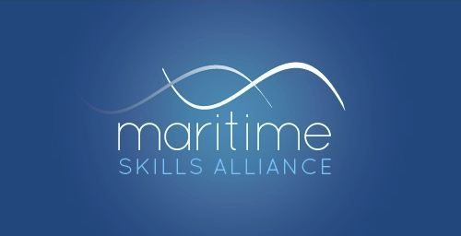
Level 2 Award in Maritime Studies: Deck Rating (QCF)

Ofqual ref: 600/2113/5 - SQA ref: GC6K 62
Candidates must achieve 12 credits (ie all the mandatory Units)
MSA Ref | Title | SQA Code | Ofqual code | QCF Level | QCF credit value | GLH
Group A: Mandatory Units
1 | Maritime Employment, Environmental and Health and Safety Practice | FA5M 54 | Y/501/2738 | 2 | 2 | 20
13 | Survival in the Water During Maritime Emergencies | FA5N 54 | Y/602/3071 | 2 | 1 | 8
14 | Vessel Fire Prevention and Fire Fighting (STCW) | FA5T 54 | T/502/5920 | 2 | 2 | 20
15 | Maritime Security | FA5P 54 | K/602/3866 | 2 | 1 | 8
16 | Emergency First Aid in Response to Maritime Accidents or Medical Emergencies | FA5R 54 | A/602/3872 | 2 | 1 | 7
23 | Basic Navigational Watchkeeping | FN04 62 | R/503/2146 | 2 | 2 | 18
24 | Vessel Ropework, Anchoring and Mooring Activities | FN02 62 | D/503/2148 | 2 | 2 | 18
25 | Assisting With Securing a Vessel for Passage | FN03 62 | Y/503/2147 | 2 | 1 | 7

