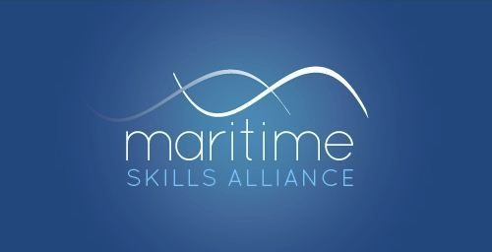
Level 2 Certificate in Maritime Studies: Able Seafarer (Deck)
Ofqual ref: 601/5700/8 - SQA ref: GK54 54
To attain the qualification candidates must complete all 5 mandatory units, worth 19 credits.

MSA Ref | Title | SQA Unit Code | Ofqual Unit code | QCF Level | QCF credit value | GLH
Group A: Mandatory Units
2 | Maritime Sector Overview | FA69 54 | D/501/2739 | 2 | 3 | 30
29 | Control Operation of Survival Craft and Rescue Boats | FF2D 57 | L/602/5321 | 3 | 3 | 30
3 | Vessel Ropework, Anchoring and mooring operations | FA60 54 | K/602/3897 | 2 | 5 | 50
4 | Securing a Vessel for Passage | FA61 54 | H/602/3901 | 2 | 3 | 28
5 | Vessel Construction and Stability | FA62 54 | T/602/3904 | 2 | 5 | 50

