 |  |  | 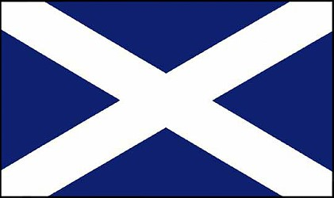  This qualification is available in Scotland

Diploma in Maritime Studies: Sea Fishing at SCQF Level 5
SQA ref: GG10 45
NB: This Diploma is no longer open for new candidates.
It has been replaced by a new Diploma with an additional Unit, ref: GM9F 45
To attain the qualification candidates must complete all 11 mandatory Units, plus one of the Optional Units in Group B.
If they wish to do so, candidates may also take the Unit in Group C.

MSQ Unit | Title | SQA Unit Code | SCQF Level | SCQF credit value | GLH
Group A: Mandatory Units - Candidates must complete all 11 Units from this group
1 | Maritime Employment, Environmental and Health and Safety Practice | H0J9 04 | 5 | 6 | 18
2 | Maritime Sector Overview | H0JA 04 | 4 | 4 | 30
3 | Vessel Ropework, Anchoring and Mooring Operations | H0JB 04 | 5 | 9 | 50
4 | Securing a Vessel for Passage | H0JC 04 | 5 | 2 | 28
5 | Vessel Construction and Stability | H0JD 04 | 5 | 3 | 50
13 | Survival in the Water During Maritime Emergencies | H0JE 04 | 5 | 2 | 8
15 | Maritime Security | H0JG 04 | 5 | 1 | 8
16 | Emergency First Aid in Response to Maritime Accidents or Medical Emergencies | H0JH 04 | 5 | 2 | 7
18 | Assemble, Operate and Maintain Fishing Gear | H2TH 04 | 5 | 12 | 50
19 | Receiving, Handling and Stowing the Catch on a Fishing Vessel | H2TJ 04 | 5 | 4 | 50
20 | Communicate using Equipment and Visual Means | H2TG 04 | 5 | 5 | 18

Group B: Optional Units - Candidates must complete either Unit 14 or Unit 17
14 | Vessel Fire Prevention and Fire Fighting (STCW) | H0JF 04 | 5 | 6 | 20
17 | Maritime Fire Prevention and Fire Actions | H2TL 04 | 4 | 2 | 8

Group C: Additional Optional Units - Candidates may also do this Unit if they wish
22 | Assist with Cooking on a Fishing Vessel | H2TK 04 | 4 | 3 | 18

