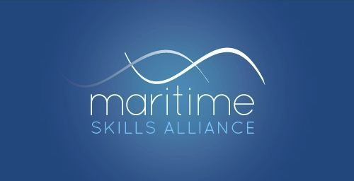
Level 4 Award in Maritime Studies:
Tug Master less than 500 gross tonnage

Ofqual ref: 601/4861/5 - SQA ref: GK0X 78
Candidates must achieve 12 credits (ie both Units)
MSA Ref | Title | SQA Code | Ofqual code | QCF Level | QCF credit value | GLH
Group A: Mandatory Units
47 | Direct Tug Operations | H81K 78 | R/602/5353 | 6 | 4 | 30
55 | Manoeuvre a Tug | H81L 78 | K/602/5407 | 6 | 4 | 30

This qualification forms part of the Maritime Studies Qualification route to Maritime and Coastguard Agency certification for Tug Masters as set out in MGN 495, and covers most of the academic work required for certification.

