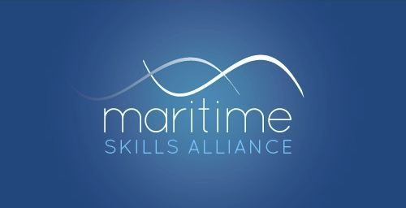
Level 4 Certificate in Maritime Studies:
Tug Master less than 3000 gross tonnage

Ofqual ref: 601/5024/5 - SQA ref: GK1V 63
Candidates must achieve 33 credits (ie all five Units)
MSA Ref | Title | SQA Code | Ofqual code | QCF Level | QCF credit value | GLH
Group A: Mandatory Units
51 | Manage Personnel on Board a Vessel | H8J5 63 | H/602/5406 | 8 | 4 | 60
52 | Manage Vessel Navigation | H8J6 63 | D/602/5372 | 8 | 4 | 60
53 | Manage Vessel Maintenance | H8J7 63 | R/602/5417 | 5 | 4 | 40
54 | Manage Vessel Operations | H8J8 63 | D/602/5386 | 8 | 4 | 60
66 | Take Charge of Medical Care on Board a Vessel | H8J9 63 | Y/602/5449 | 4 | 4 | 35

This qualification forms part of the Maritime Studies Qualification route to Maritime and Coastguard Agency certification for Tug Masters as set out in MGN 495, and covers most of the academic work required for certification.

