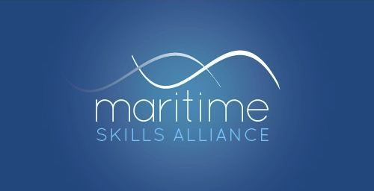
Level 3 Diploma in Maritime Studies: Officer of the Watch on Merchant Vessels of less than 500 Gross Tonnage (Near Coastal)
Ofqual ref: 600/8403/0 - SQA ref: GG77 57
To attain the qualification candidates must complete all 7 mandatory units, worth 39 credits.
They may also take as many of the Additional Optional Units as they wish, or none.

MSA Ref | Title | SQA Unit Code | Ofqual Unit code | QCF Level | QCF credit value | GLH
Group A: Mandatory Units
37 | Ship Construction | FF2C 57 | K/602/5441 | 3 | 5 | 45
41 | Chartwork and Tides | H3LP 57 | L/602/5318 | 3 | 8 | 80
43 | Contribute to Vessel Stability and Watertight Integrity | H3LR 57 | R/602/5319 | 3 | 8 | 70
46 | Control Vessel Mooring, Anchoring and Securing Operations | H3LS 57 | Y/602/5323 | 3 | 4 | 20
48 | Interpret Meteorology in the Near Coastal Area | H3LT 57 | L/602/5366 | 3 | 5 | 45
62 | Respond to Navigational Emergencies | H3LV 57 | M/602/5411 | 3 | 3 | 20
11 | Vessel Navigation and Tides | FA7J 70 | H/504/7958 | 3 | 6 | 55

Group B: Additional Optional Units
44 | Control Tug Operations | H3LW 57 | R/602/5322 | 3 | 5 | 30
59 | Provide Fire Fighting Response on Board a Vessel | FT31 57 | Y/602/5435 | 3 | 3 | 30
60 | Provide Medical First Aid on Board a Vessel | H3M1 57 | D/602/5436 | 3 | 3 | 30
63 | Take Charge of a Navigational Watch in the Near Coastal Area | H3M3 57 | A/602/5444 | 3 | 8 | 70
88 | Control Marine Radar and Automatic Identification Systems | H3M7 57 | T/504/1132 | 3 | 5 | 42
89 | Control Marine Electronic Navigation Systems | H3M8 57 | F/504/1134 | 3 | 8 | 70
90 | Control Electronic Chart Display Information Systems ECDIS | H3M9 57 | l/504/1136 | 3 | 3 | 25
91 | Control Bridge Resources | H3MA 57 | A/504/1133 | 3 | 3 | 24

