 | 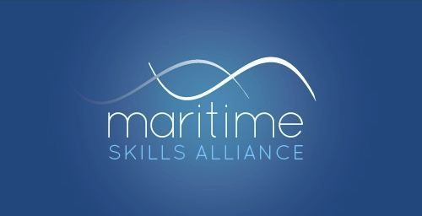 |  | 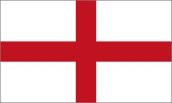  This qualification is available in England

Level 3 Award in Maritime Studies: Use of Radar and Electronic Chart Systems in Code Vessels

Ofqual ref: 601/7697/0 - SQA ref: GK9V 69
Candidates must achieve 4 credits (ie both Units)
MSA Ref | Title | SQA Code | Ofqual code | QCF Level | QCF credit value | GLH
104 | Use of Radar for Safe Navigation and Collison Avoidance on Domestic and Code Vessels | H6RB 57 | K/506/0079 | 3 | 2 | 20
115 | Operate non-ECDIS Marine Electronic Chart Systems | H9R2 69 | K/506/4620 | 3 | 2 | 20

Purpose | This qualification was designed by the Workboat Association in response to new requirements in the Workboat Code.  This qualification is only currently available in England.
Links to MCA Certification | The Maritime and Coastguard Agency’s information page on the revised Workboat Code is here.
Qualification information | For full information on the requirements of the Scottish Qualifications Authority for this qualification click here.
Who offers it? | Maritas and Sea Regs

