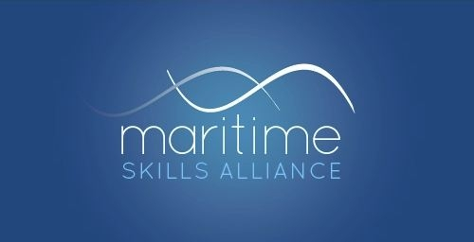
www.maritimeskills.org

Shipping & Maritime Operations: A united access qualification at SCQF Level 6 & RQF Level 3?

Providers across the UK use three closely-related qualifications to do two jobs:

- Support the first year of a Cadet’s HNC programme
- Offer a year-long access course, from which many students go on to start Cadetships

They are these:

- National Certificate in Shipping and Maritime Operations at SCQF Level 6: G9GW 46
- Level 3 Diploma in Maritime Studies: Shipping and Maritime Operations (Deck): GA6F 57
- Level 3 Diploma in Maritime Studies: Shipping and Maritime Operations (Engine Room): GA6G 57

The Scottish qualification was created back in 2009, and the two English ones were developed from it in 2011.

At the suggestion of Shajan Lukose of Fleetwood Nautical Campus, a small working group has had an initial look to see how far these qualifications are still fit for the purposes for which they are used.

The group reached three conclusions:

- the model of a core plus a more specialist option is a good one;
- the “access” function which the qualifications perform could usefully be extended beyond the current deck and engine room options, opening-up access to other options, such as ETO, or the ports sector;
- SQA would take the opportunity to make the qualifications identical in structure, content and output, ie a single qualification (with options) for the whole of Great Britain.

SQA has asked Shajan Lukose to conduct a scoping exercise to determine what, if any, changes are might be made to the qualification. The review will cover both ways to improve what already exists (eg removing duplication in assessment), and ways to enhance it, in both the core and the options.

The Scoping Report will draw information from a wide range of sources: EV reports, feedback from centres and other desk-based research, and consultation with stakeholders including approved centres, lecturers, industry, and representative bodies, particularly the MNTB and MSA. The report is to be ready by the end of February 2020. Contact: Shajan.Lukose@blackpool.ac.uk

Iain Mackinnon
Secretary
iain@maritimeskills.org
December 2019

